Mercado de Derivados - Banxico
https://www.banxico.org.mx/IndicadoresGraficos/actions/contenidoPortal/mercadosFin/1/4?menu=7&seccion=19#
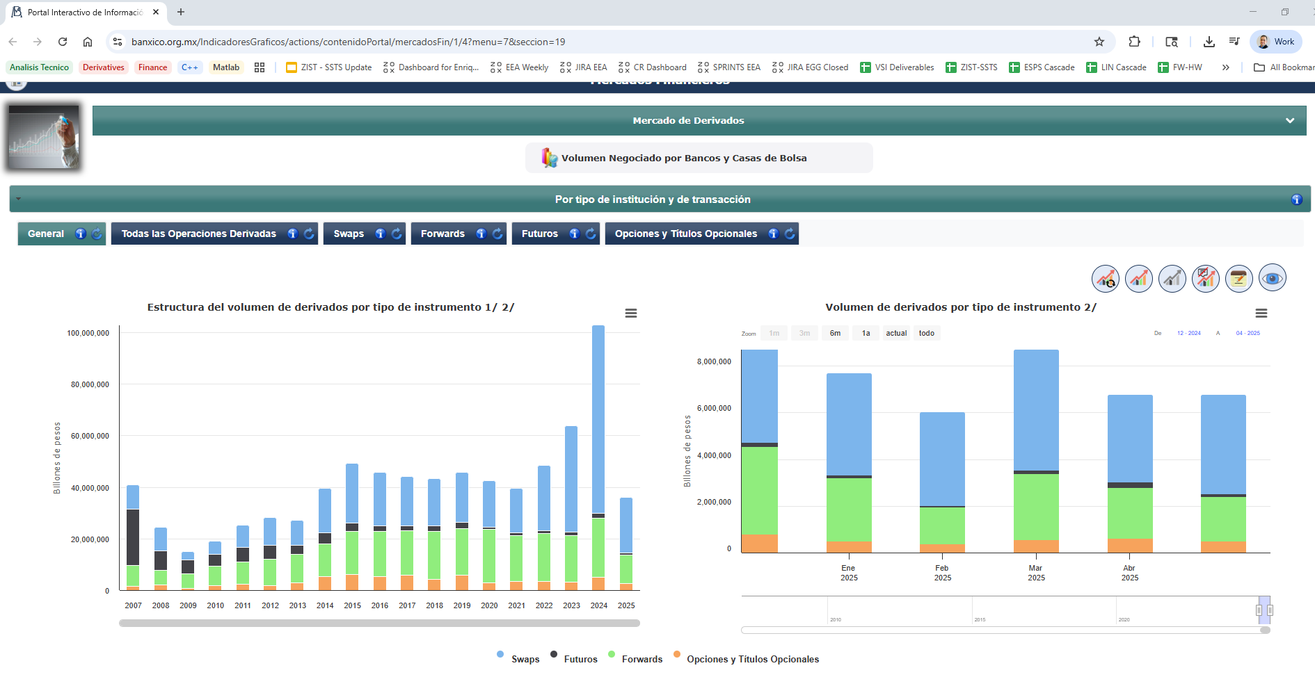

CME Group All Products – Codes and Slate (pizarra)
https://www.cmegroup.com/markets/products.html#sortAsc&sortField=vol&sortDirection=desc
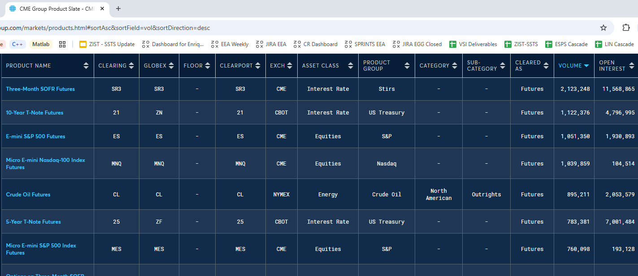
Asset Classes - International Swaps and Derivatives Association (ISDA)
https://www.isda.org/category/asset-classes/
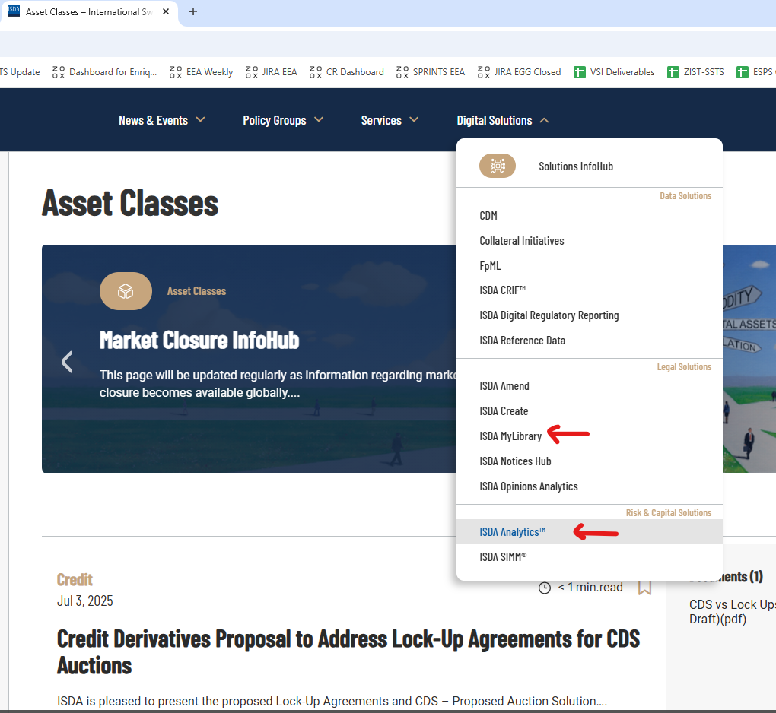

¿Quién es el Mtro. José Luis Reyes García?
https://www.youtube.com/watch?v=X2S0JTY4C4o
